**Scenario 4 – Export Oriented & Uncontrolled**

**Scenario description**

This scenario applies the same filters as Scenario 3 (export filter + removal of outliers) but adds an **RPT filter**, restricting the sample to uncontrolled firms only. The applied filters are:

* **Net worth > 0**
* **Persistent loss = 0**
* **Employee cost ≥ 25% of OR**
* **Service income ≥ 75% of OR**
* **Operating revenue between 1 and 30,000**
* **PLI between 0 and 50**
* **Export income ≥ 75% of OR**
* **RPT_%<25%**

Final sample sizes: **FY 2021-22: 148**, **FY 2022-23: 151**, **FY 2023-24: 144** firm-year observations.

**Results:**

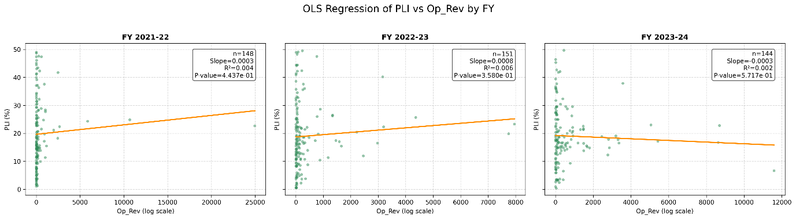

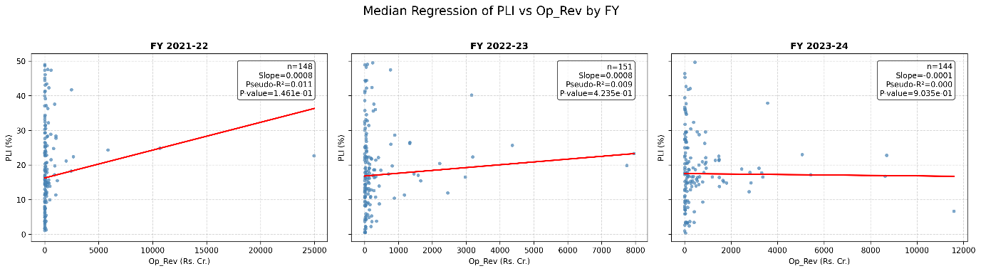

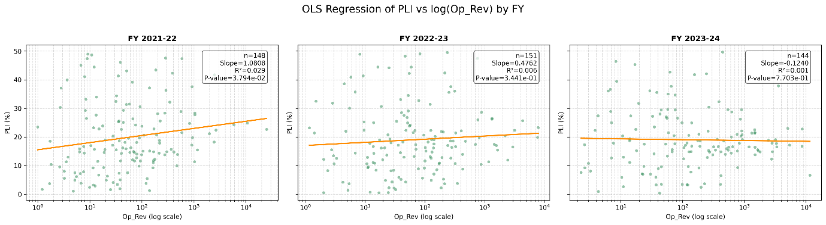

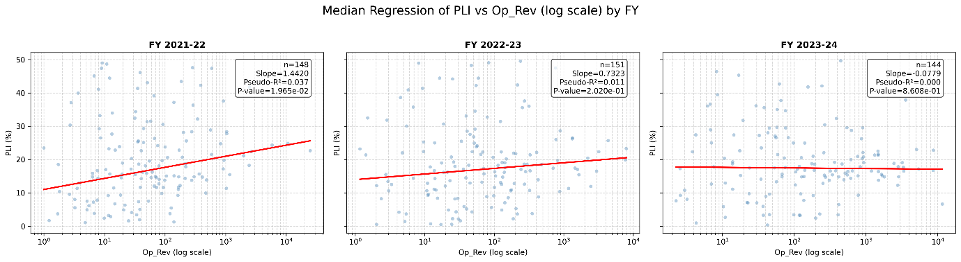

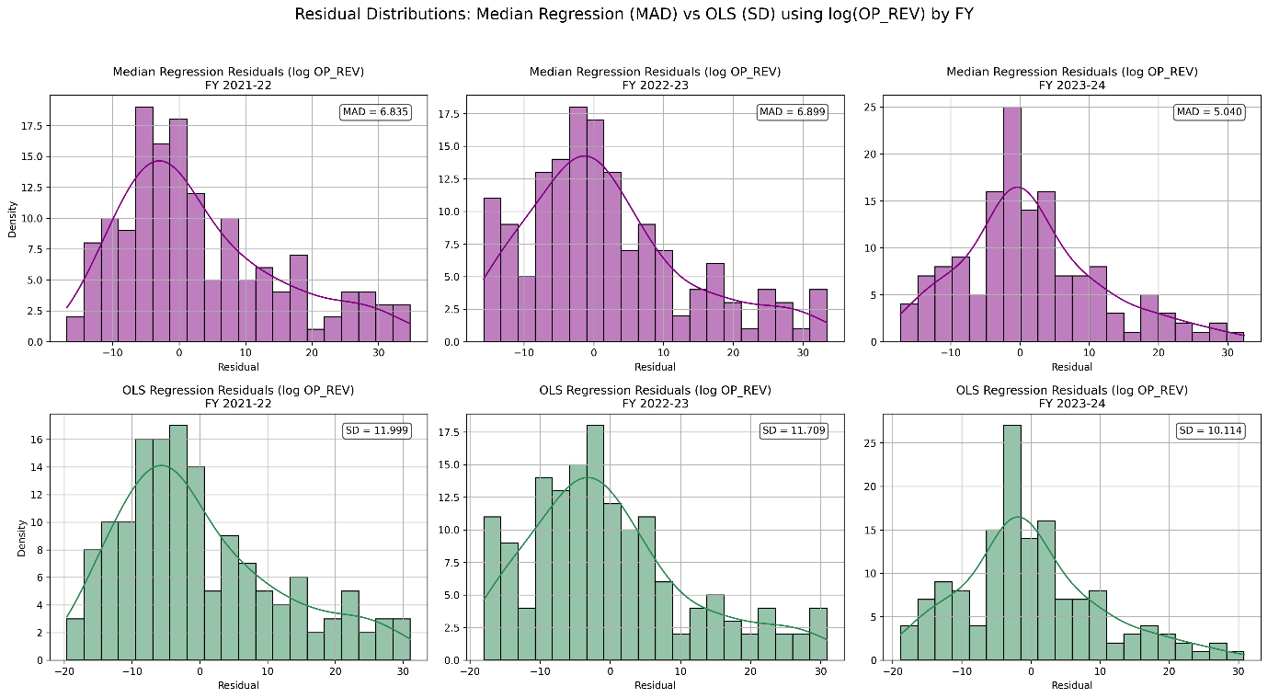

**Interpretation:**

**1. Sample Size**

* Very small dataset (n ≈ 144–151 per FY), compared to 1,400+ in Scenario-2.
* Indicates only a limited set of truly comparable uncontrolled, export-oriented IT/ITeS companies survive after strict filters.
* Small n → higher sensitivity of slope estimates, noisier results.

**2. PLI vs Operating Revenue (linear scale)**

* **Median regression slopes**: small, positive in 2021-22 & 2022-23, but statistically insignificant; negative in 2023-24.
* **OLS slopes**: similar direction, none significant.
* **Takeaway** → On raw scale, no meaningful linear relationship between size (op_rev) and profitability.

**3. PLI vs Log(Operating Revenue)**

* **2021-22**:
  + Median regression slope = **1.44** (p = 0.0196, pseudo-R² ≈ 0.037) → significant.
  + OLS slope = **1.08** (p = 0.038, R² ≈ 0.029) → significant.
  + Interpretation: **positive size effect** – larger export-oriented uncontrolled companies earned higher PLI.
* **2022-23 & 2023-24**:
  + Slopes drop and lose significance (p > 0.2, p > 0.8).
  + Suggests the 2021-22 effect did not persist consistently across years.

**4. Residuals (Fit Quality)**

* Median regression MAD: ~5–7
* OLS residual SD: ~10–12
* Again, median regression gives **tighter residuals** → more robust fit against outliers even in small sample.

**Interpretation for Policy / TP Safe Harbour Context**

* When filtering strictly to **export-oriented, uncontrolled companies**,
  + The relationship between firm size and profitability **is weak or unstable** across years.
  + A statistically significant positive slope appears in **2021-22**, but **not robust across 2022-23 and 2023-24**.
  + This suggests that **size is not a reliable driver of PLI in this narrowly defined uncontrolled set**.
* Median regression provides more consistent residual control, but even then explanatory power is low (pseudo-R² ≤ 0.04).

**Overall Takeaway:**  
Scenario-4 confirms that once you restrict to **pure export-oriented uncontrolled comparables**, the **size-profitability link largely disappears** (except one year blip). This makes a strong case that **PLI ranges should not be adjusted for size effects under such strict comparability filters**, since the relationship is not systematic across years.

**Prediction Table:**

